Stash –SSH Configuration Steps.

- Install Git in your computer.
- Through Git Bash you can do the following to generate SSH Public key.
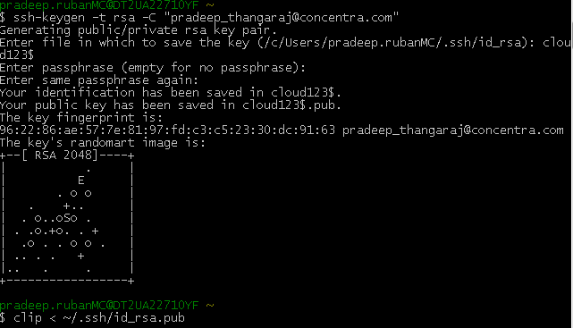

- Once public key generated copy the public key using clip command as mentioned above.
- Once copied login to stash url and do the following
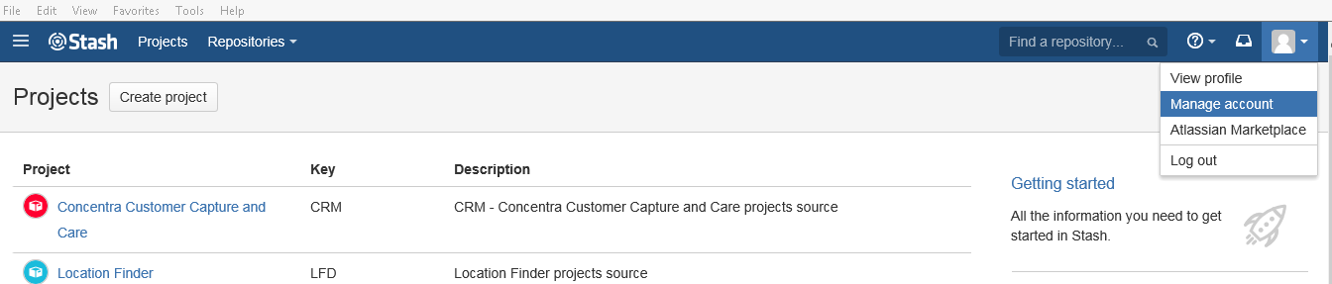

- Click Manage account and click SSH in the left panel.
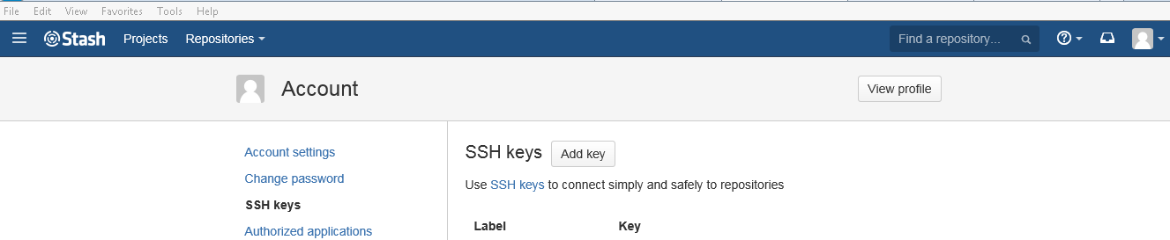
- Click Add Key Button
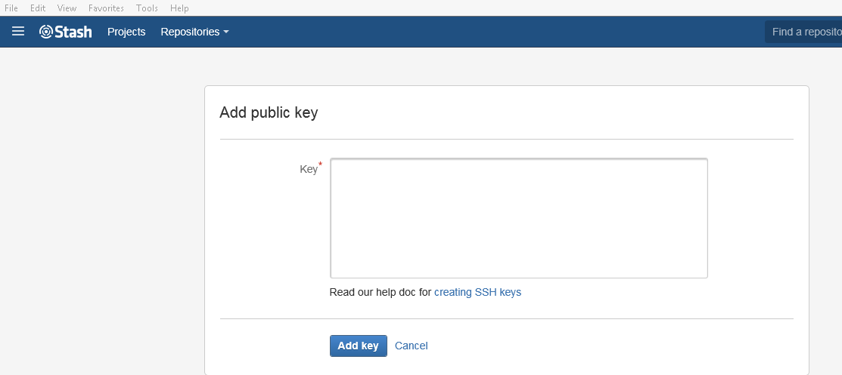

- In Git Bash, we have used clip command to copy the public key, paste the key in the text area given and click Add key.

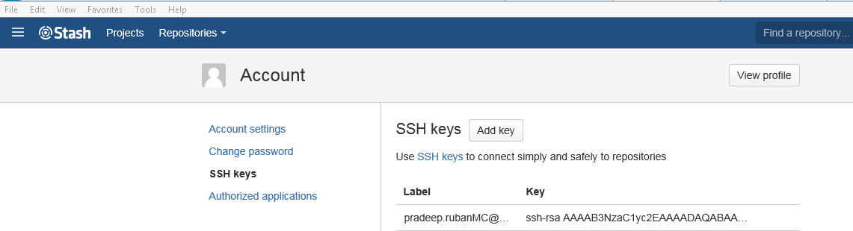

- So from above it shows that we have added SSH key generation to our Stash repository.

Finally we need to the following changes in the TortoiseGit settings.

- TrotoiseGit -> Settings -> Network -> SSH Client , we need to point the below configuration
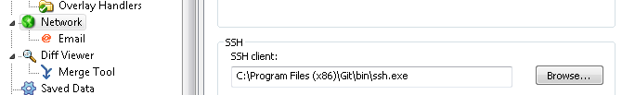

- Once above settings done , now we are ready to go ahead with checkout and commit the code using SSH in Stash.

